**PRANAV SANDEEP RAIKAR**

**D10A 43**

**EXPT 4:**

**AIM:To create a simple simulation using NS2 with two**

**Expt 4**

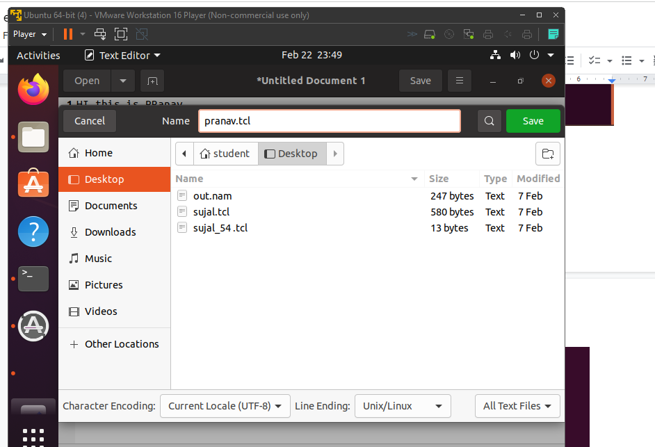

For creating link between 2 nodes

Code:

